1. **An array contains 20 integers randomly. Write a java program to sort them in ascending order**

**Code:-**

/*Write a program to input 20 random integers and sort using quick sort in ascending order

Author:Debayan De

*/

// Java program for implementation of QuickSort

class QuickSort

{

int partition(int arr[], int low, int high)

{

int pivot = arr[high];

int i = (low-1); // index of smaller element

for (int j=low; j<high; j++)

{

// If current element is smaller than or

// equal to pivot

if (arr[j] <= pivot)

{

i++;

// swap arr[i] and arr[j]

int temp = arr[i];

arr[i] = arr[j];

arr[j] = temp;

}

}

// swap arr[i+1] and arr[high] (or pivot)

int temp = arr[i+1];

arr[i+1] = arr[high];

arr[high] = temp;

return i+1;

}

/* The main function that implements QuickSort()

arr[] --> Array to be sorted,

low --> Starting index,

high --> Ending index */

void sort(int arr[], int low, int high)

{

if (low < high)

{

/* pi is partitioning index, arr[pi] is

now at right place */

int pi = partition(arr, low, high);

// Recursively sort elements before

// partition and after partition

sort(arr, low, pi-1);

sort(arr, pi+1, high);

}

}

/* A utility function to print array of size n */

static void printArray(int arr[])

{

int n = arr.length;

for (int i=0; i<n; ++i)

System.out.print(arr[i]+" ");

System.out.println();

}

// Driver program

public static void main(String args[])

{

int arr[] = {20,19,18,17,16,15,14,13,12,11,10,9,8,7,6,5,4,3,2,1};

int n = arr.length;

QuickSort ob = new QuickSort();

ob.sort(arr, 0, n-1);

System.out.println("sorted array");

printArray(arr);

}

}

**Output:-**

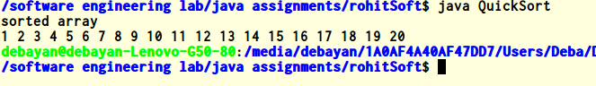

**2.Write a java program that receives a integer no less than 20 and give factorial as output using recursive function call**

**Code:**

/*Write a program to find the factorial of a number recursively

Author:- Debayan De

*/

import java.util.Scanner;

class FactorialDemo{

public static void main(String args[]){

//Scanner object for capturing the user input

Scanner scanner = new Scanner(System.in);

System.out.println("Enter the number:");

//Stored the entered value in variable

int num = scanner.nextInt();

//Called the user defined function fact

int factorial = fact(num);

System.out.println("Factorial of entered number is: "+factorial);

}

static int fact(int n)

{

int output;

if(n==1){

return 1;

}

//Recursion: Function calling itself!!

output = fact(n-1)* n;

return output;

}

}

**Output:-**

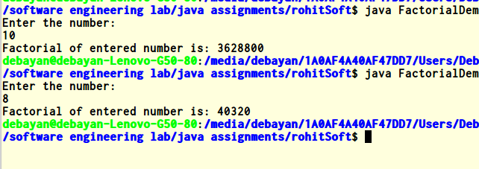

**3.You are starting out on a long way.On the way there are N gas stations,the location of which are given as 1,2..N.Initially you are located at the gas station at 1 and your destination is N.Your car can run M station without refueling.Now you wish to plan your trip such that no of intermediate stop is minimum.**

**Input:-N and M.**

**Output:-The number of stop and the number of ways to trip**

**Code:-**

/*Assignment 2

*Author:-Ddebayan De

*cs791

*q3

*/

import java.io.BufferedReader;

import java.io.InputStreamReader;

import java.io.PrintWriter;

class Solution_MinStop{

public static final int MOD = 1000000007;

public static void main(String[] args) throws java.io.IOException {

BufferedReader rd = new BufferedReader(new InputStreamReader(System.in));

PrintWriter wr = new PrintWriter(System.out);

String[] tokens = rd.readLine().split(" ");

int n = Integer.parseInt(tokens[0]);

int m = Integer.parseInt(tokens[1]);

int[] array = new int[n];

for (int i = 0; i < n; i++) {

array[i] = Integer.parseInt(rd.readLine());

}

int dp[] = new int[n];

int arr[] = new int[n];

long counter = 0;

int k = 0;

int j = 0;

dp[0] = 1;

for (int i = 1; i < n; i++) {

while (array[i] - array[j] > m) {

counter -= dp[j];

j++;

}

arr[i] = arr[j] + 1;

while (arr[k] == arr[j]) {

counter += dp[k];

k++;

}

dp[i] += counter % MOD;

}

wr.println((arr[n-1]-1) + " " + dp[n-1]);

wr.close();

}

}

**Output:-**

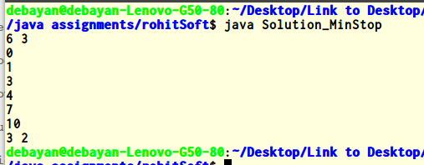

**4.Given N separate integer points on the Cartesian plane satisfying there is no any other sharing same x coordinate.Count the no of rectangles created from any four of given points.**

**Code:-**

/*

* Assignment 2

*Author:Debayan De

*cs791

*q4

*/

import java.io.*;

import java.util.*;

import java.math.*;

import java.lang.*;

class Point implements Comparable<Point>

{

int x,y;

public Point(int x1,int y1)

{

x=x1;

y=y1;

}

public int compareTo(Point p)

{

if(p.x<x)

return 1;

if(p.x>x)

return -1;

if(p.y<y)

return 1;

if(p.y>y)

return -1;

return -1;

}

}

class Pair

{

int a,b;

public Pair(int x,int y)

{

a=x;

b=y;

}

@Override

public boolean equals(Object obj) {

if (obj == null) {

return false;

}

if (getClass() != obj.getClass()) {

return false;

}

final Pair other = (Pair) obj;

if (this.a != other.a) {

return false;

}

if (this.b != other.b) {

return false;

}

return true;

}

@Override

public int hashCode() {

int hash = 3;

hash = 23 * hash + this.a;

hash = 23 * hash + this.b;

return hash;

}

}

public class Main {

/**

* @param args the command line arguments

*/

public static void main(String[] args) {

// TODO code application logic here

try

{

Parserdoubt pd=new Parserdoubt(System.in);

while(true)

{

int n=pd.nextInt();

if(n==0)break;

Point pts[]=new Point[n];

for(int i=0;i<n;i++)

pts[i]=new Point(pd.nextInt(),pd.nextInt());

Arrays.sort(pts);

HashMap <Pair,Integer> map=new HashMap<Pair,Integer>();

long counts[]=new long[100000];

int c=0;

for(int i=1;i<pts.length;i++)

{

if(pts[i].x==pts[i-1].x)

{

int tmp1=pts[i-1].y;

int tmp2=pts[i].y;

Pair tmp=new Pair(tmp1,tmp2);

if(map.containsKey(tmp))

{

counts[map.get(tmp)]++;

}

else

{

map.put(tmp, c++);

}

}

}

long sum=0;

for(int i=0;i<c;i++)

{

long temp=counts[i]*(counts[i]+1);

temp/=2;

sum+=temp;

}

System.out.println(sum);

}

}

catch(Exception e)

{

e.printStackTrace();

}

}

}

class Parserdoubt

{

final private int BUFFER_SIZE = 1 << 17;

private DataInputStream din;

private byte[] buffer;

private int bufferPointer, bytesRead;

public Parserdoubt(InputStream in)

{

din = new DataInputStream(in);

buffer = new byte[BUFFER_SIZE];

bufferPointer = bytesRead = 0;

}

public String nextString() throws Exception

{

StringBuffer sb=new StringBuffer("");

byte c = read();

while (c <= ' ') c = read();

do

{

sb.append((char)c);

c=read();

}while(c>' ');

return sb.toString();

}

public char nextChar() throws Exception

{

byte c=read();

while(c<=' ') c= read();

return (char)c;

}

public int nextInt() throws Exception

{

int ret = 0;

byte c = read();

while (c <= ' ') c = read();

boolean neg = c == '-';

if (neg) c = read();

do

{

ret = ret * 10 + c - '0';

c = read();

} while (c > ' ');

if (neg) return -ret;

return ret;

}

public long nextLong() throws Exception

{

long ret = 0;

byte c = read();

while (c <= ' ') c = read();

boolean neg = c == '-';

if (neg) c = read();

do

{

ret = ret * 10 + c - '0';

c = read();

} while (c > ' ');

if (neg) return -ret;

return ret;

}

private void fillBuffer() throws Exception

{

bytesRead = din.read(buffer, bufferPointer = 0, BUFFER_SIZE);

if (bytesRead == -1) buffer[0] = -1;

}

private byte read() throws Exception

{

if (bufferPointer == bytesRead) fillBuffer();

return buffer[bufferPointer++];

}

}

**Output:-**

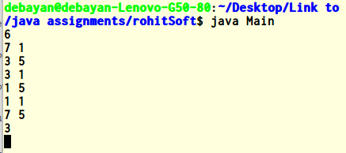

**5.Given two stings,write a program that convert one string to other with minimum change**

**Code:-**

/* A Naive recursive Java program to find minimum number

operations to convert str1 to str2

Author:-Debayan De

*/

class EDIST

{

static int min(int x,int y,int z)

{

if (x<=y && x<=z) return x;

if (y<=x && y<=z) return y;

else return z;

}

static int editDist(String str1 , String str2 , int m ,int n)

{

// If first string is empty, the only option is to

// insert all characters of second string into first

if (m == 0) return n;

// If second string is empty, the only option is to

// remove all characters of first string

if (n == 0) return m;

// If last characters of two strings are same, nothing

// much to do. Ignore last characters and get count for

// remaining strings.

if (str1.charAt(m-1) == str2.charAt(n-1))

return editDist(str1, str2, m-1, n-1);

// If last characters are not same, consider all three

// operations on last character of first string, recursively

// compute minimum cost for all three operations and take

// minimum of three values.

return 1 + min ( editDist(str1, str2, m, n-1), // Insert

editDist(str1, str2, m-1, n), // Remove

editDist(str1, str2, m-1, n-1) // Replace

);

}

public static void main(String args[])

{

String str1 = "sunday";

String str2 = "saturday";

System.out.println( editDist( str1 , str2 , str1.length(), str2.length()) );

}

}

**Output:-**

**C:\Users\Deba\Desktop\software engineering lab\java assignments\5.png**

**6.A nxn magic square generation**

**Code:-**

// Java program to generate odd sized magic squares

//Author:-Debayan De

import java.io.*;

class GFG

{

// Function to generate odd sized magic squares

static void generateSquare(int n)

{

int[][] magicSquare = new int[n][n];

// Initialize position for 1

int i = n/2;

int j = n-1;

// One by one put all values in magic square

for (int num=1; num <= n*n; )

{

if (i==-1 && j==n) //3rd condition

{

j = n-2;

i = 0;

}

else

{

//1st condition helper if next number

// goes to out of square's right side

if (j == n)

j = 0;

//1st condition helper if next number is

// goes to out of square's upper side

if (i < 0)

i=n-1;

}

//2nd condition

if (magicSquare[i][j] != 0)

{

j -= 2;

i++;

continue;

}

else

//set number

magicSquare[i][j] = num++;

//1st condition

j++; i--;

}

// print magic square

System.out.println("The Magic Square for "+n+":");

System.out.println("Sum of each row or column "+n*(n*n+1)/2+":");

for(i=0; i<n; i++)

{

for(j=0; j<n; j++)

System.out.print(magicSquare[i][j]+" ");

System.out.println();

}

}

// driver program

public static void main (String[] args)

{

// Works only when n is odd

int n = 7;

generateSquare(n);

}

}

**Output:-**

